**COMPARISON OF STRUCTURAL RESPONSES FOR A BASE ISOLATED BUILDING UNDER REAL AND SIMULATED RECORDS**

**DOI 10.13753/2686-7974-2019-16-1133-1139**

Volkan OZSARAC[1], Shaghayegh KARIMZADEH[2], Aysegul ASKAN[3]

**ABSTRACT**

In recent decades, base isolation systems for buildings are commonly used as retrofitting strategy in earthquake-prone areas. Evaluation of structural responses for base-isolated systems subjected to severe earthquakes is challenging since some regions have scattered ground motion dataset. Simulated ground motions can be an alternative to overcome this issue. There are several ground motion simulation methods available that provide varying levels of goodness fit between observed and synthetic data; therefore, simulated motions need to be investigated in terms of their efficiency in the prediction of alternative structural demands corresponding to base-isolated buildings. Herein, a six-story steel moment-resisting frame is selected from the SAC Steel Project and retrofitted with lead rubber bearings in accordance with ASCE 7‐10. Then, nonlinear time-history analysis of the structure is carried out using the real and simulated records of the 6 April 2009 L′Aquila (Italy) earthquake (Mw=6.3). For this purpose, simulated records generated based on the Hybrid Integral-Composite method are employed. Results of analyses are compared in terms of alternative response parameters including inter-story drifts, base displacements, base shear and accelerations at each story level. Overall, the difference in terms of the real and estimated demand parameters from the ground motion simulation technique is negligible.

*Keywords: Base Isolation; Steel Moment-Resisting Frame; Real Ground Motions; Simulated Ground Motions; Structural Response Parameter*

**1. INTRODUCTION**

Under the framework of performance based-design (PBD) of important buildings such as hospitals and office buildings, one may not only limit the inter-story drifts a structure may experience during its lifetime but also the floor accelerations that can cause significant losses due the non-structural components. Hence base isolators are nowadays widely used in these buildings and considered as one of the most effective devices to control structural vibrations. As much more computer-based analysis tools are becoming available, base isolated structures are usually being designed and assessed with the use of nonlinear time-history analysis that requires set of ground motion records. Therefore, the estimation of the hazard and selection of the records are crucial steps to design and assess the structure adequately. In the absence of the strong ground motion data for the region, the most common approach is to use set of records from other regions with similar seismotectonics. However, the real records may still not be eligible to represent regional seismic or the potential seismic demand on the structures as indicated by Katsanos (2010). Synthetic ground motions represent the regional sources, path and site effects and can be used as alternative options to avoid this issue after being scaled to the design level spectra that is also encouraged by the building codes such as EC08 (1998) and ASCE/SEI 7-10 (2010).

Previously, several attempts have been made on the use of simulated ground motions in nonlinear time history analyses of single-degree-of-freedom (SDOF) systems (e.g: Bazzurro et al. 2004, Krishnan et al. 2006, Atkinson et al. 2010, Galasso et al. 2012). In some of these studies, the simulated ground motions were validated against the real ground motions while in others dynamic response of structures are evaluated using synthetic records. Recently, Karimzadeh (2017) studied the dynamic response of multi-degree-of-freedom (MDOF) structures under simulated ground motions and compared the results against responses obtained using observed ground motions. Yet, the study of structural response of base isolated MDOF structures to synthetic records remains to be studied. For this purpose, the typical base isolated frame building is analyzed using synthetic records and compared with real records in terms of different engineering demand parameters. Simulated records of the 2009 L′Aquila earthquake generated based on the Hybrid Integral-Composite method are employed.

**2. Input Ground Motion Dataset**

The input ground motion dataset used for analyses corresponds to the real and simulated ground motion records of the 2009 L’Aquila (Italy) earthquake (Mw=6.3). Seven stations that recorded this event are selected. The information corresponding to the selected stations with their properties is provided in Table 1. The real records at these stations are taken from the Italian ground motion dataset (<http://itaca.mi.ingv.it>). The simulated records from the Hybrid Integral-Composite approach introduced by Gallovic and Brokesova (2007) for the selected stations are used. Simulations are previously validated by Ameri et al. (2012) by comparison against the real records of the 2009 L’Aquila earthquake at the stations. The simulation approach is based on the representation theorem with a k-squared slip distribution over the fault plane for simulation of the low-frequency band. This method applies a composite application of Brune’s source time functions with a proper seismic moment and corner frequency for simulating the high-frequency range. To obtain the final ground motion record, the ground motion amplitudes are combined in a cross-over frequency range. Further details of simulations can be found in Ameri et al. (2012) and Karimzadeh et al. (2017). Table 1 also includes the simulated PGA values in both EW and NS directions from HIC method. It is observed that at station AQA, PGA is well simulated in EW direction while there is a difference between the real and simulated PGAs in the NS direction. When the real and simulated PGA values at station CLN are compared, underestimation of the PGA levels at both EW and NS directions is observed by HIC ground motion simulation method. At this station, the level of underestimation is higher for the EW component of the real record than the NS component. The simulated PGAs at stations MTR and SUL do not match with the observed values in both directions with an underestimation of the real values. At the other stations, the real and simulated PGAs match each other closely.

Table 1. Information on the selected seven stations of the 2009 L’Aquila earthquake

|  |  |  |  |  |  |  |  |  |
| --- | --- | --- | --- | --- | --- | --- | --- | --- |
| **Station Code** | **Latitude**  **(°)** | **Longitude**  **(°)** | **Site Class** **(****EC8)** | **REPI (km)** | **Observed**  **PGA-NS** **(cm/s2)** | **Observed**  **PGA-EW**  **(cm/s2)** | **Simulated PGA-NS**  **HIC (cm/s2)** | **Simulated PGA-EW**  **HIC (cm/s2)** |
| AQA | 42.376 | 13.339 | B | 4.6 | 347.59 | 350.46 | 196.96 | 341.18 |
| CLN | 42.085 | 13.521 | A | 31.64 | 76.57 | 73.49 | 50.72 | 23.75 |
| FMG | 42.268 | 13.117 | A | 19.32 | 24.53 | 20.12 | 30.38 | 28.44 |
| GSA | 42.421 | 13.519 | B | 18.05 | 139.02 | 131.88 | 103.31 | 195.26 |
| LSS | 42.558 | 12.969 | A | 39.02 | 7.61 | 9.21 | 6.21 | 5.41 |
| MTR | 42.524 | 13.245 | A | 22.35 | 51.65 | 42.17 | 16.21 | 14.44 |
| SUL | 42.090 | 13.934 | C | 56.53 | 24.53 | 27.04 | 8.37 | 5.41 |

**3. Description of the Structural Models**

***3.1 Building Definition***

The building structure considered in this study consists of a 6-storey moment-resisting steel framed building which was originally designed and studied previously by Tsai and Popov (1988). Later, Hall (1995) modified the structure for compatibility with newer codes where strong column-weak beam design rule is enforced. Further details of the building are provided by Christopoulos and Filiatrault (2006). The design complies with the 1994 UBC code requirements (ICBO 1994) for a building located in Zone 4 on soil type S2. The building has no irregularities and it is rectangular in shape, with the main lateral-resistance in the North-South direction being provided by two exterior moment-resisting frames (highlighted in red in Figure 1a). These consist of 6-storey 3-span frames (see Figure 1b). Design gravity loads include the roof dead load (3.8 kPa), the floor dead load (4.5 kPa), the roof live load (1.0 kPa), the floor live load (3.8 kPa), and the weight of the exterior cladding (1.7 kPa). The steel grade is assumed to be A36 (nominal Fy = 290 MPa) for all members.

a)

b)

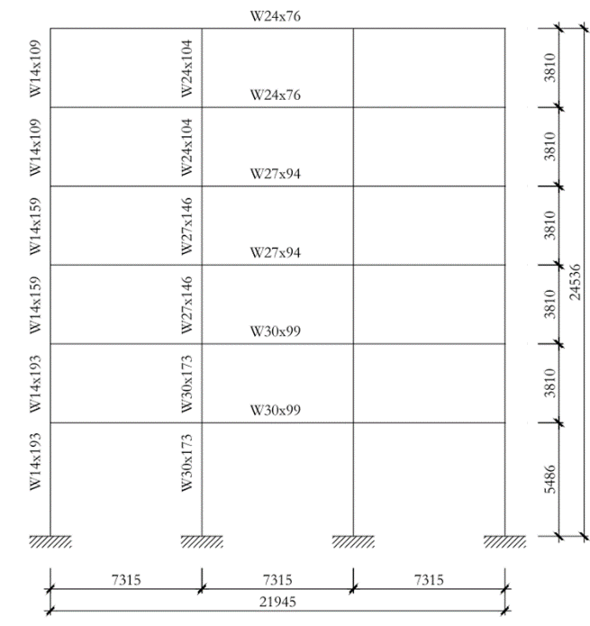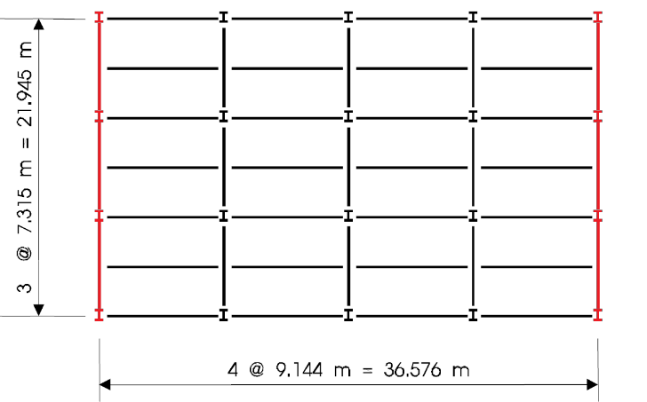

Figure 1. (a) Plan and (b) elevation views of the structure

***3.2 Numerical Model***

The 2-D analyses are carried out in North-South direction using OpenSees software (Mazzonni et al. 2006). Taking advantage of the symmetry of the building, only half of the structure is modeled. As shown in Figure 2, the model includes one of the exterior frames, together with one gravity column that represents all interior frame columns, as per a lean-column approach. The total gravity loads acting on the interior columns are applied to this lean-column, thus ensuring that the additional second-order effects are considered. The gravity column is assumed pinned at the base and at each level. Gravity loads acting on the frame during the earthquake are assumed equal to the roof and floor dead loads, the weight of the exterior walls, and a portion of the floor live load (0.7 kPa). P-delta effects are accounted for in the analyses, including P-delta forces generated in the interior frames. Half the weight of the building, along with a 0.5 kPa live load, is included in the reactive weights at each level. Rayleigh damping of 5% based on the first two elastic modes of vibration of the structure is assigned. All analyses are performed at a time-step increment of 0.002s. For simplification purposes, only the bare steel frame is included in the analyses, i.e., the slab participation as a composite beam was not accounted for. The fundamental period of vibration for the bare frame without the isolators is obtained from eigenvalue analysis as 1.3 seconds assuming fixed connection at the ground level. The structure is retrofitted considering the target displacement of 250mm, the effective period of the base isolated structure is estimated as 2.8 sec and the equivalent damping ratio as 27%. In total six isolators (LRB) were considered for one half of the structure. The assumed hysteresis loop for each isolator is depicted in Figure 2 where k1=7.24 KN/mm, k2=0.83 KN/mm and Fy=215.75 KN. The base level nodes are released in the direction of the earthquake, and rigid diaphragm is assigned to the base level nodes, intended to account for the existence of a rigid link frame (with a weight of 2000kN). The additional mass of the rigid link frame is distributed to the base level nodes. A new node fully fixed node is created at the same location as the base of the exterior column at the left, making use of a zerolength Element, defined with two uniaxial springs where the properties of isolators are concentrated: i) the first spring was set with the uniaxialMaterial Elastic with the stiffness of the rubber bearing; ii) the second spring was defined with uniaxialMaterial ElasticPP representing the lead material. In the model, the inelastic response is concentrated at specific regions of the structural members, following a concentrated plasticity approach. Plastic hinges that could form at both ends of the frame members are assumed, to which the bilinear moment-curvature model depicted in Figure 3a is assigned. The plastic hinge length is assumed as the 90% of the section depth and the failure criterion assumed for all steel structural members is based on a plastic end rotation limit of 30mrad. Rigid-end offsets are specified at the end of the frame members to account for the actual size of the members at the joints. The panel zones of the beam-column connections are assumed to be stiff and strong enough to avoid any panel shear deformation and yielding under strong earthquakes. This assumption represents the most critical condition for the inelastic curvature demand on the welded beam-to-column joints, as all the hysteretic energy must be dissipated only through plastic hinging in the beams and the columns. To capture the brittle failure of the welded beam-to-column connections, the flexural strength degradation model shown in Figure 3b is introduced at the ends of the beam and column elements. In this model, the yield levels in the interaction diagrams may be reduced as a function of the curvature ductility in each direction. The strength degradation begins at a curvature ductility of 11.0. At a curvature ductility of 11.55, the strength reduces to 1% of the yield moment which is close enough to zero for engineering purposes.

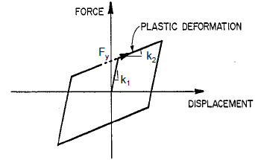 

Figure 2. Representation of numerical model

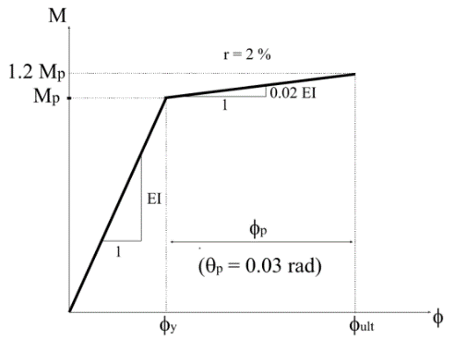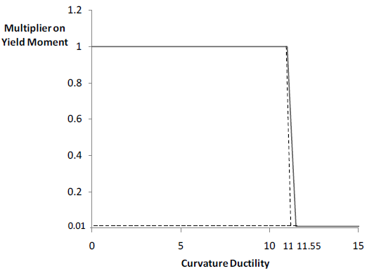

(а) (b)

Figure 3. a) Bi-linear moment-curvature model b) flexural strength degradation model for welded steel-column

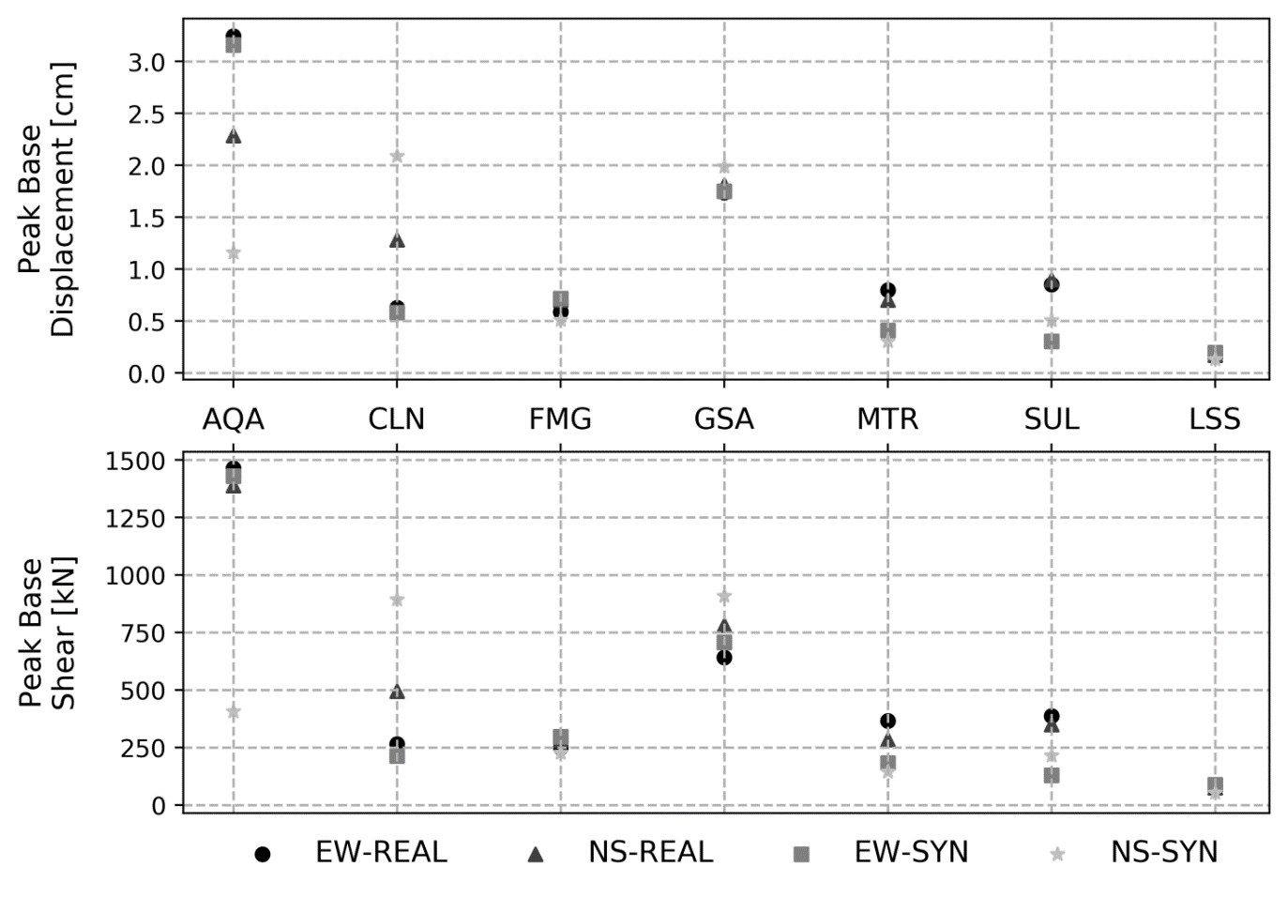

b)

a)

Figure 4. Comparison of peak base displacement and peak base shear values for different stations

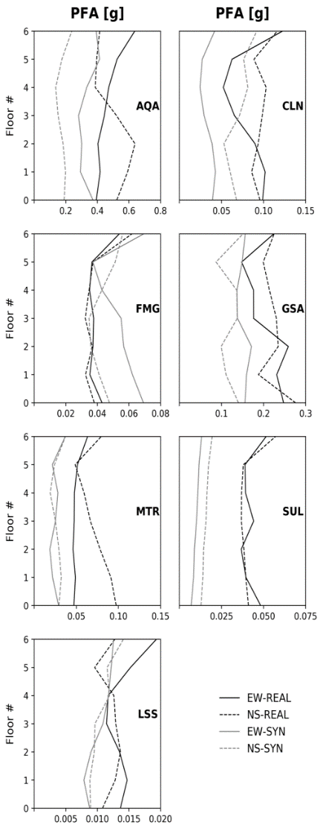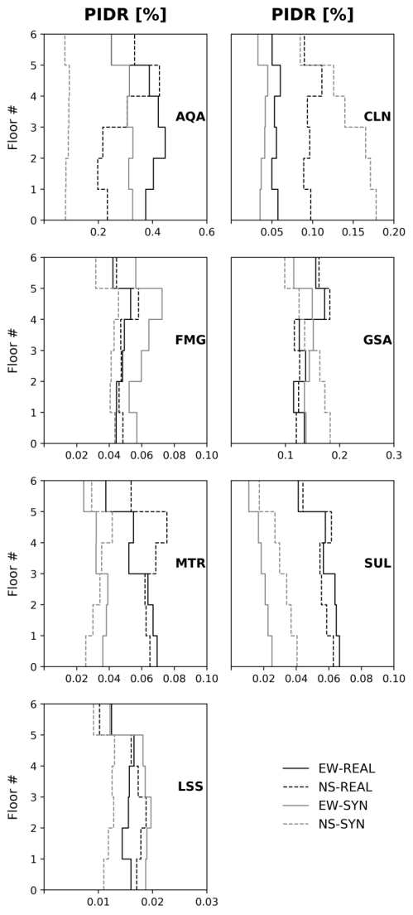

Figure 5. Comparison of peak floor accelerations (PFA) and peak inter-story drift ratios (PIDR) for different stations

**4. Analyses Results**

The main objective of this study is to investigate whether the nonlinear dynamic response of the base

isolated structures to simulated ground motions are consistent with observed ground motions or not. The comparison is made between two cases in terms of peak base displacement, peak base shear, peak floor accelerations and peak inter-storey drifts (Figures 4 and 5). The first two parameters are rather important to design isolator devices whereas the other two parameters are the main interests in PBD approach. The analyses are carried out without applying any scaling factor to the records. As expected, the upper structures remain elastic while the isolators undergo the inelastic deformations. When the results are evaluated at all stations, it is observed that the NS component of the simulated ground motion at station AQA underestimates the response by a factor of 2-3 in terms of all the parameters presented here. At station CLN, the predicted acceleration demand is nearly half of the real one while other parameters are overestimated by a factor of 2 to 3. At stations SUL and MTR, the demand parameters obtained with synthetic ground motions are slightly lower than the ones obtained using real records in both EW and NS. There seems to be a better match at the other stations for all parameters of interest. Overall, although there are some differences, responses from observed and simulated records can be considered as consistent. The numerical results in this study reveal that when a close match is obtained between the observed and simulated records at a station, the structural response at that station from the simulated record is also consistent with the response under the corresponding observed record.

**5. Conclusions**

In this study, a six-story steel moment-resisting frame is considered in order to investigate the efficiency of the ground motion simulations in predicting alternative structural responses. For this purpose, nonlinear time-history analysis of the selected frame is performed using the real and simulated ground motion records of the 6 April 2009 L′Aquila (Italy) earthquake (Mw=6.3). For structural analyses, the simulated records corresponding to the 2009 L′Aquila earthquake from the Hybrid Integral-Composite method at selected 7 stations are employed. Analyses results from the real and simulated ground motion sets for this earthquake are compared in terms of different seismic demand parameters including inter-story drifts, base displacements, base shear and accelerations at each story level.

Following findings are obtained in this study:

* Overall, it is observed that despite some discrepancies, the selected structural responses for the base-isolated structure of interest from the real and simulated records are in agreement at most stations.
* It is particularly observed that when a close match is obtained between the observed and simulated records at a station, the structural response at that station from the simulated record is also consistent with the response under the corresponding observed record.
* The close match in terms of both seismological and structural parameters can be attributed to the efficiency of the Hybrid Integral-Composite ground motion simulation method in simulating the broad frequency band of the observed records.
* Finally, the numerical results demonstrate that simulated motions provide alternative record sets for events with sparse observed records. In addition, whenever regional and realistic physical data for the seismic events are employed in simulation process, past and potential destructive events can be studied extensively for seismological and structural purposes.

**6. Acknowledgments**

The numerical model used in this study is developed in the context of the Seismic Isolation and Dissipation module of the ROSE Master 2016-2017 programme at IUSS Pavia and presented in the project report entitled Seismic performance assessment and retrofit of a steel moment-resisting frame (Silva et al. 2017). Authors would like to thank Mr. António Silva, Mr. Davit Shahnazaryan, Mr. Ömer Odabaşı, Mr. Pablo Garcia De Quevedo and Paul R. Steneker who made significant contribution to development of this numerical model.

**7. References**

Karimzadeh, S., Askan, A., Yakut, A., Ameri, G. (2017) Assessment of alternative simulation techniques in nonlinear time history analyses of multi-story frame buildings: a case study. Soil Dynamics and Earthquake Engineering, (98): 38-53.

Ameri, G., Gallovič, F., Pacor, F. (2012) Complexity of the Mw 6.3 2009 L’Aquila (central Italy) earthquake: Broadband strong-motion modeling. Journal of Geophysical Research, 117, B04308.

Tsai, K.C., Wu, S., Popov, E.P. (1995) Cyclic Performance of Steel Beam-Column Moment Joints, Engineering Structures 17 (8): 596–602.

CEN (2004) EN 1998–1 Eurocode 8: Design of Structures for Earthquake Resistance, Part 1, General Rules, Seismic Actions and Rules for Buildings, European Commitee for Standardization (CEN), Brussels, Belgium

Galasso C., Zareian F., Iervolino I., Graves R.W. Elastic and post-elastic response of structures to Hybrid Broadband synthetic ground motions, in: Proceedings of the 9th International Conference on Urban Earthquake Engineering/4th Asia Conference on Earthquake Engineering, 6-8 March 2018, Tokyo Institute of Technology, Tokyo, Japan.

Gallovič F, Brokešová J. (2007) Hybrid k-squared source model for strong ground motion simulations: introduction. Physics of the Earth and Planetary Interiors (160): 34–50.

Atkinson G.M., Goda K. (2010) Inelastic seismic demand of observed versus simulated ground-motion records for Cascadia subduction earthquakes. Bulletin of the Seismological Society of America, (100): 102–15.

ICBO. (1994) Uniform Building Code - Vol 2. International Conference of Building Officials, Whittier, California.

Luzi L., Pacor F., Puglia R. (2017) Italian Accelerometric Archive v 2.2. Istituto Nazionale di Geofisica e Vulcanologia, Dipartimento della Protezione Civile Nazionale. Doi: 10.13127/ITACA.2.2

ASCE (2010) ASCE/SEI 7-10: Minimum Design Loads for Buildings and Other Structures, American Society of Civil Engineers (ASCE), Virginia, USA.

Mazzoni, S., McKenna, F., Scott, M.H., Fenves, G.L. (2006) “OpenSees command language manual”, Pacific Earthquake Engineering Research (PEER) Center.

Krishnan S., Ji C., Komatitsch D., Tromp J. (2006) Performance of two 18-story steel moment-frame buildings in southern California during two large simulated San Andreas earthquakes. Earthquake Spectra, (22): 1035–61.

Bazzurro P., Sjoberg B., Luco N. (2004) Post-Elastic Response of Structures to Synthetic Ground Motions, Technical Report AT2, for PEER lifelines program project 1G00, AIR Worldwide Co, San Francisco.

Christopoulos, C., Filiatrault, A. (2006) Principles of Passive Supplemental Damping and Seismic Isolation, IUSS Press, University of Pavia, Italy.

Motazedian D., Atkinson G.M. (2005) Stochastic finite-fault modeling based on a dynamic corner frequency. Bulletin of the Seismological Society of America, (95): 995–1010.

Silva, A., Shahnazaryan, D., Odabasi, O., Quevedo, P. G. D., Ozsarac, V. (2017) Seismic Performance Assessment and Retrofit of a Steel Moment-Resisting Frame. Doi: 10.13140/RG.2.2.10276.78726

Katsanos E.I., Sextos A.G., Manolis G.D. (2010). Selection of Earthquake Ground Motion Records: A State-of-the-art Review from a Structural Engineering Perspective, Soil Dynamics and Earthquake Engineering 30 (4): 157–69.

Tsai, K.C., E.P. Popov. (1988) Steel Beam-Column Joints in Moment Resisting Frames. Earthquake Engineering Research Center, University of California at Berkeley. ReportUCB/EERC 88/19.

1. Graduate Student, Institute for Advanced Study of Pavia (IUSS), Pavia, Italy, volkan.ozsarac@iusspavia.it
2. Instructor, Doctor, Middle East Technical University (METU), Civil Engineering Department, Turkey, Ankara, shaghkn@metu.edu.tr
3. Professor, Middle East Technical University (METU), Departments of Civil Engineering and Earthquake Studies, Turkey, Ankara, aaskan@metu.edu.tr